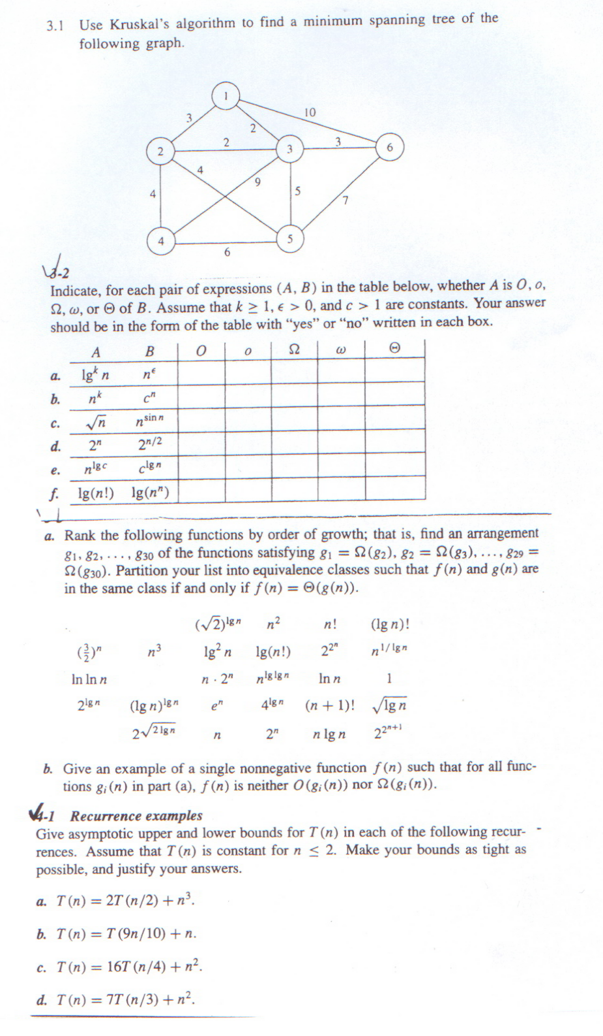
Design and Analysis of Algorithms
Homework 1
Due: March 23, 2010

